10.19: The acceleration of the mass is related to the tension by 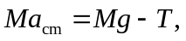 and the angular acceleration is related to the torque by have been used.
a) Solving these for 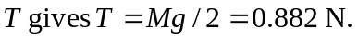 b) Substituting the expression for T into either of the above relations gives 